SIMATS ENGINEERING
ASSESSMENT TOOL 2

NAME:M.Gowtham kumar REG.NO: 192525163
COURSE NAME:CSA1603 COURSE CODE: Data Warehousing and Data Mining

COURSE OUTCOME COVERED

CO4: Examine the applicability of clustering algorithms in real-world scenarios, presenting findings through clear reports with effective visualizations.
Assessment Tool Weightage: 40%

QUESTIONS: 05 Total Marks:50

Annexure A

Industry Problem Solving Task

Criteria | Understanding of Industry Problem (2) | Application of  Engineering  Concepts  (2.5) | Solution  Design  (2.5) | Use of  Tools (2) | Analysis (1) | Total(10)
Weightage | 20% | 25% | 25% | 20% | 10% | 100%
Q1
Q2
Q3
Q4
Q5

Code of Conduct:

I __ M.Gowtham kumar/192525163__ (Name / Reg No) certify that this submission is my original work and that I have adhered to the guidelines specified for this assessment.
I understand that any violation of academic integrity rules will result in disciplinary action.
Signature of the student: M.Gowtham kumar

RUBRICS FOR CALCULATION:

Criteria | Weighta ge | Level 4 –  Exemplary | Level 3 –  Proficient | Level 2 –  Developing | Level 1 –  Beginning
Criteria | Weightag  e | Level 4 –  Exemplary | Level 3 –  Proficient | Level 2 –  Developing | Level 1 –  Beginning
Understandi  ng of  Industry  Problem | 20% | Comprehens  ive  understandi  ng of  real-world  problem and constraints | Good understandi ng with  minor gaps  in  requirement  s | Basic understandi ng; some  requirement s unclear | Poor understandi  ng;  misinterpret  s problem context
Application  of  Engineering Concepts | 25% | Applies advanced  and relevant concepts  effectively to solve the problem | Applies appropriate concepts  with minor errors | Limited application of concepts | Incorrect or no  application of concepts
Solution Design | 25% | Innovative, practical,  and feasible solution  aligned with industry standards | Logical and feasible  solution with minor gaps | Basic solution  with limited feasibility | Unclear or impractical solution
Use of Tools | 15% | Effective use of modern tools,  technologies  , and real data | Appropriate use of tools  with correct  implementat  ion | Limited or inconsistent use of tools | Minimal or incorrect use of tools
Analysis | 10% | Thorough analysis with  validated  results and  performance evaluation | Good analysis with reasonable validation | Basic analysis  with limited validation | Poor or no analysis
Professionali sm | 5% | Highly professional,  well-docume nted, and clearly | Good documentati on and presentation | Basic documentati on with some gaps | Poor documentati on and  presentatio n
 |  | presented work

Annexure A
Q1 . Dataset: Supermarket Purchases

Customer Visits/Month Avg Spend (₹) Items Bought
C1 | 10 | 2000 | 15
C2 | 4 | 5000 | 8
C3 | 12 | 1800 | 18
C4 | 3 | 6000 | 6
C5 | 11 | 2100 | 16
Question:
Using the above dataset, propose a clustering approach to segment customers and explain how it supports targeted marketing. (BL3 – 7 Marks)
ANSWER: Supermarket Purchases

Clustering Technique: K-Means Clustering
K-Means is suitable for segmenting customers according to their shopping behavior. The features Visits/Month, Average Spend, and Items Bought are used for clustering. Input
Customer | Visits | Avg Spend | Items
C1 | 10 | 2000 | 15
C2 | 4 | 5000 | 8
C3 | 12 | 1800 | 18
C4 | 3 | 6000 | 6
C5 11 2100 16

Industry Application
The supermarket can provide loyalty rewards and frequent-purchase offers to Cluster 1, while Cluster 2 can receive premium offers and incentives to increase visit frequency.

OUTPUT:

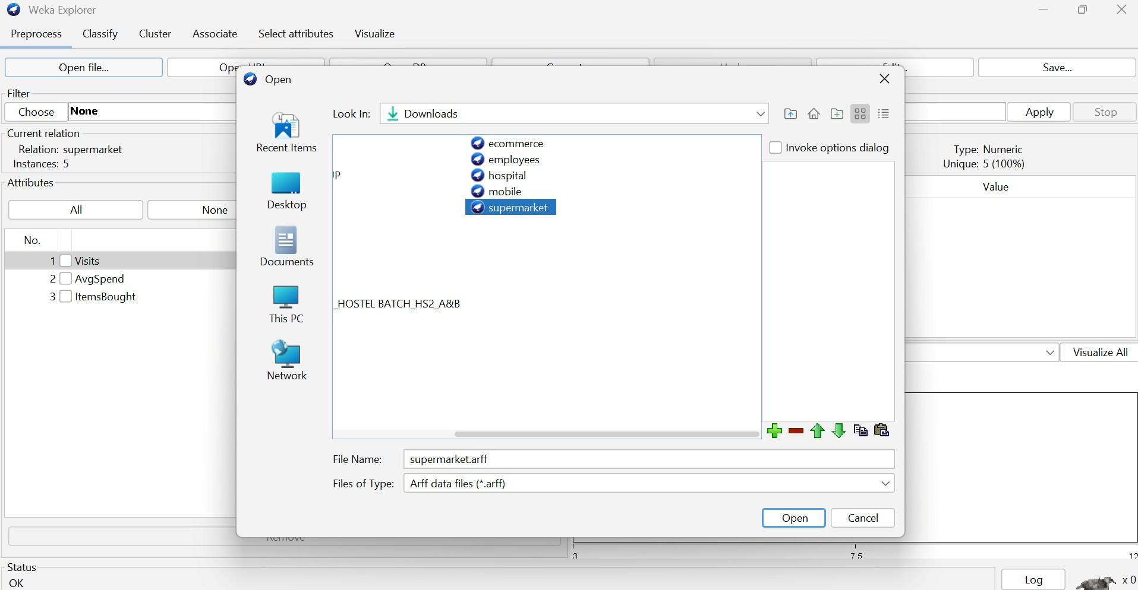

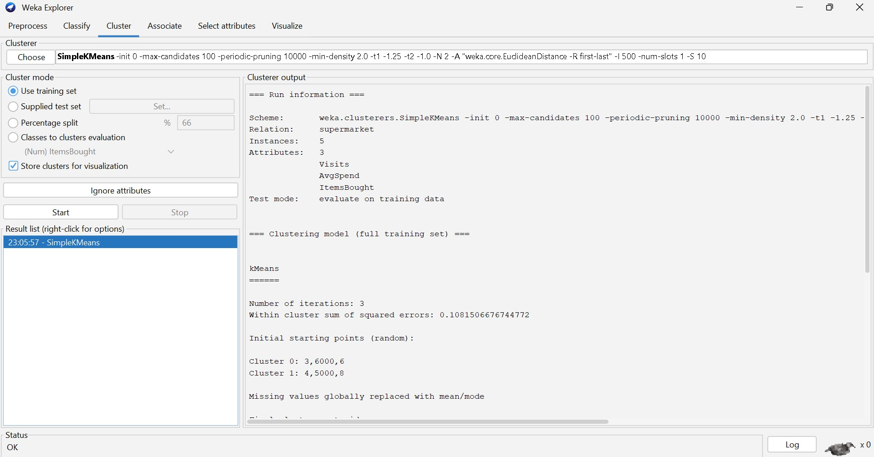
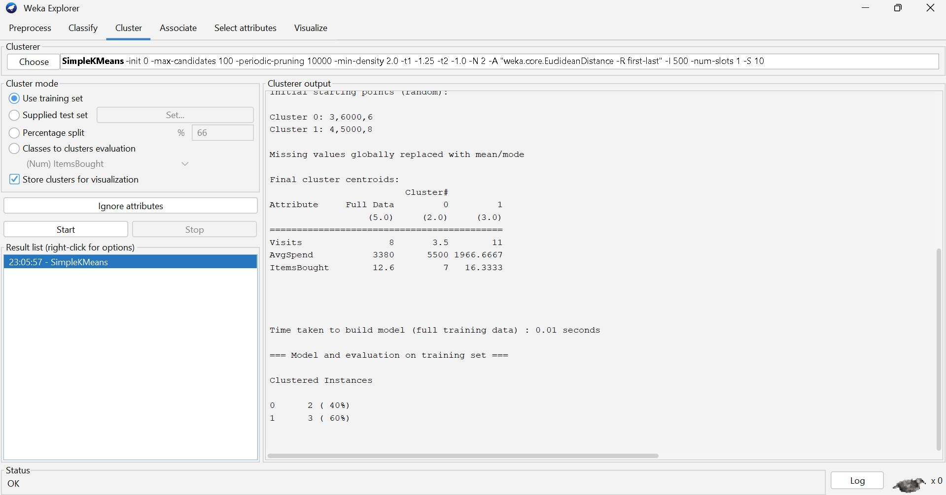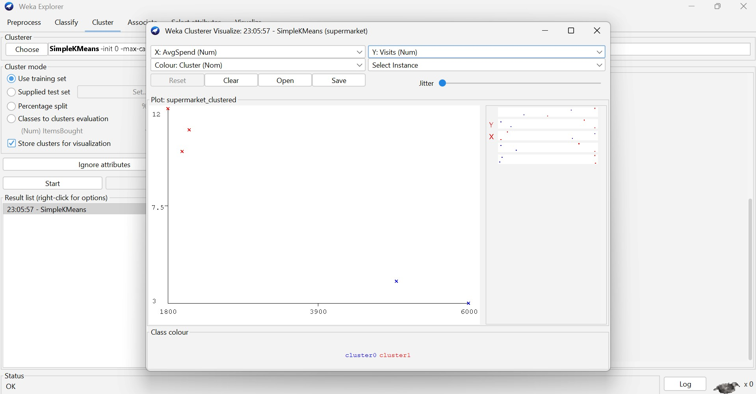

Analysis
Using K-Means with K = 2, customers can be divided into two behavioral groups:
- Cluster 1: C1, C3, C5 — frequent visitors with more items purchased.
- Cluster 2: C2, C4 — less frequent but higher-spending customers. Conclusion
K-Means helps the supermarket identify customer segments based on purchasing behavior, enabling personalized and targeted marketing.

Q2. Dataset: Credit Card Transactions

Transaction Amount (₹) Location Time (hrs)
T1 | 200 | Chennai 10
T2 | 5000 | Delhi 2
T3 | 150 | Chennai 11

Transaction Amount (₹) Location Time (hrs)
T4 7000 Mumbai 1 T5 180 Chennai 12
Question:
Design a clustering-based solution using this dataset to detect unusual or fraudulent transactions. (BL4 – 7 Marks)

ANSWER: Credit Card Transactions

Clustering Technique: K-Means Clustering
K-Means can group transactions according to transaction amount, location, and transaction time. Unusual transactions that differ significantly from normal clusters can be flagged for investigation.

Input
Transaction | Amount | Location | Time
T1 | 200 | Chennai | 10
T2 | 5000 | Delhi | 2
T3 | 150 | Chennai | 11
T4 | 7000 | Mumbai | 1
T5 180 Chennai 12
Location is encoded numerically before clustering.

OUTPUT:
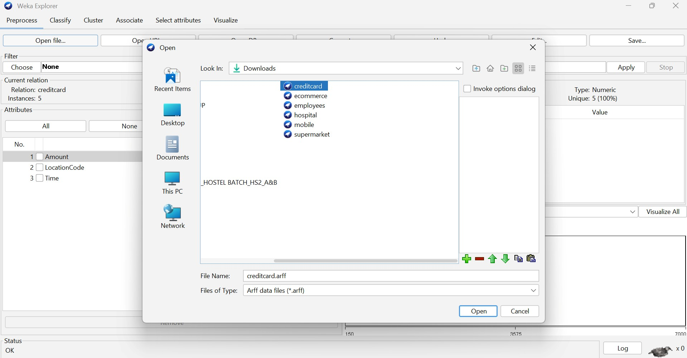
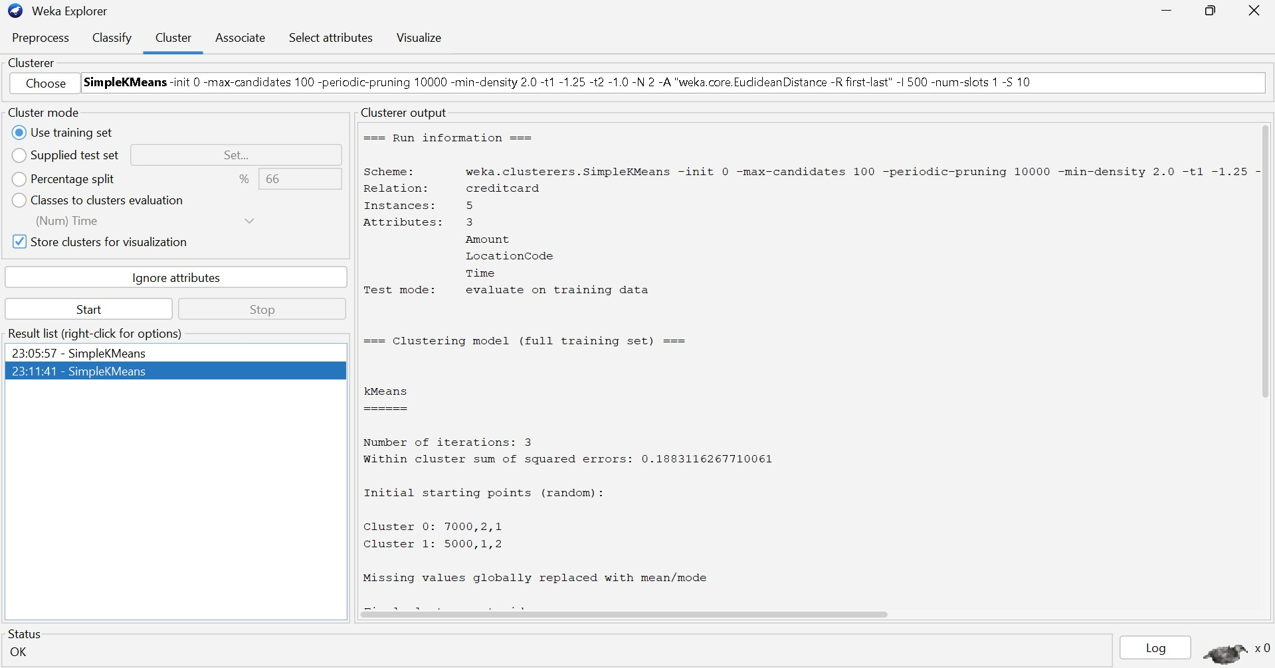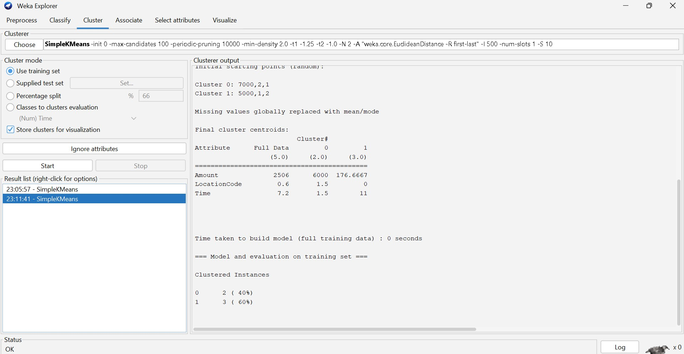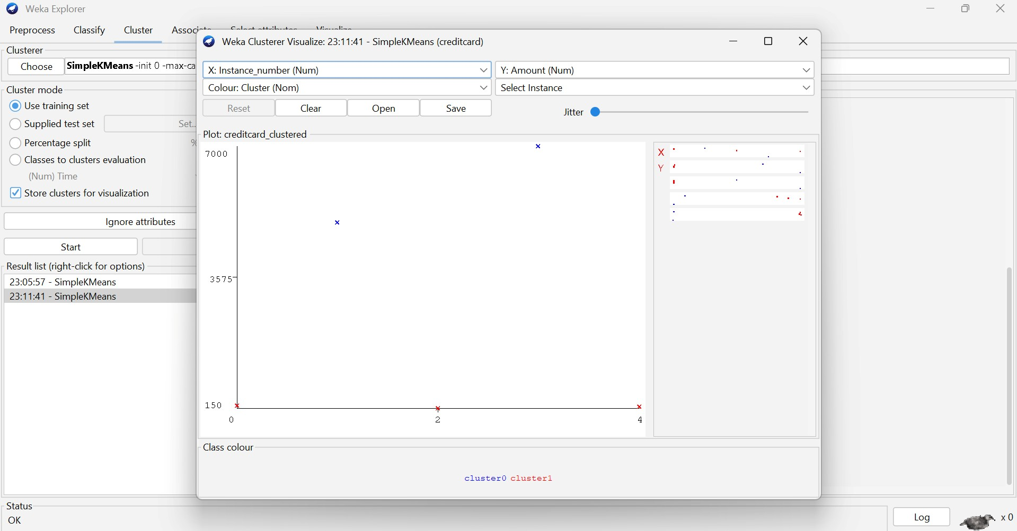

Analysis
The transactions T1, T3, and T5 show similar characteristics: low amounts, Chennai location, and daytime transactions.
T2 and T4 have significantly higher transaction amounts and occur during early morning hours in different locations. Therefore, they can be identified as potential anomalies. Industry Application
The bank can flag unusual transactions for additional authentication, customer verification, or fraud investigation.

Conclusion
Clustering can be used as an anomaly-detection technique to identify transactions that differ significantly from normal transaction patterns. It does not by itself prove fraud but helps prioritize transactions for investigation.

Q3. Dataset: Telecom Usage

User Call Duration (min) Data Usage (GB) Recharge (₹)
U1 | 300 | 5 | 200
U2 | 100 | 2 | 100
U3 | 350 | 6 | 220
U4 | 80 | 1 | 90
U5 | 320 | 5.5 | 210
Question:
Explain how clustering can be applied to identify churn-prone users and improve customer retention strategies. (BL4 – 7 Marks)
ANSWER: Telecom Usage

Clustering Technique: K-Means Clustering
K-Means can group telecom users according to call duration, data usage, and recharge amount.

Input
User | Call Duration | Data Usage | Recharge
U1 | 300 | 5 | 200
U2 | 100 | 2 | 100
U3 | 350 | 6 | 220
U4 | 80 | 1 | 90
U5 320 5.5 210

OUTPUT:
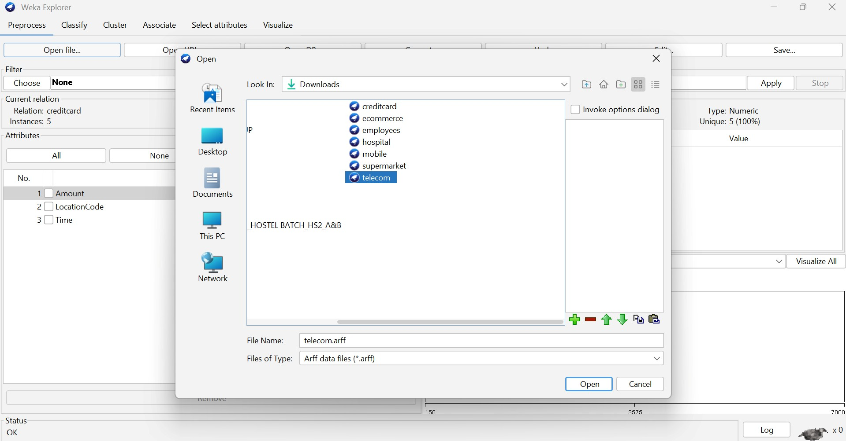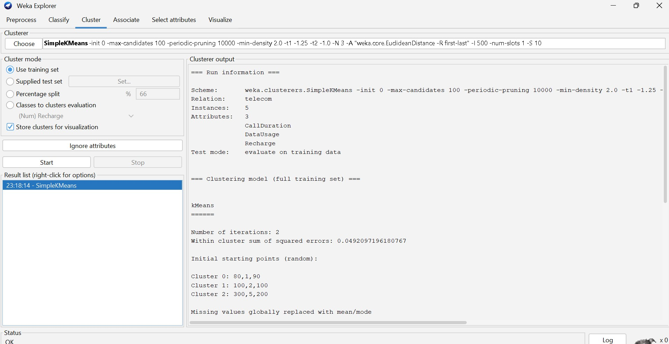

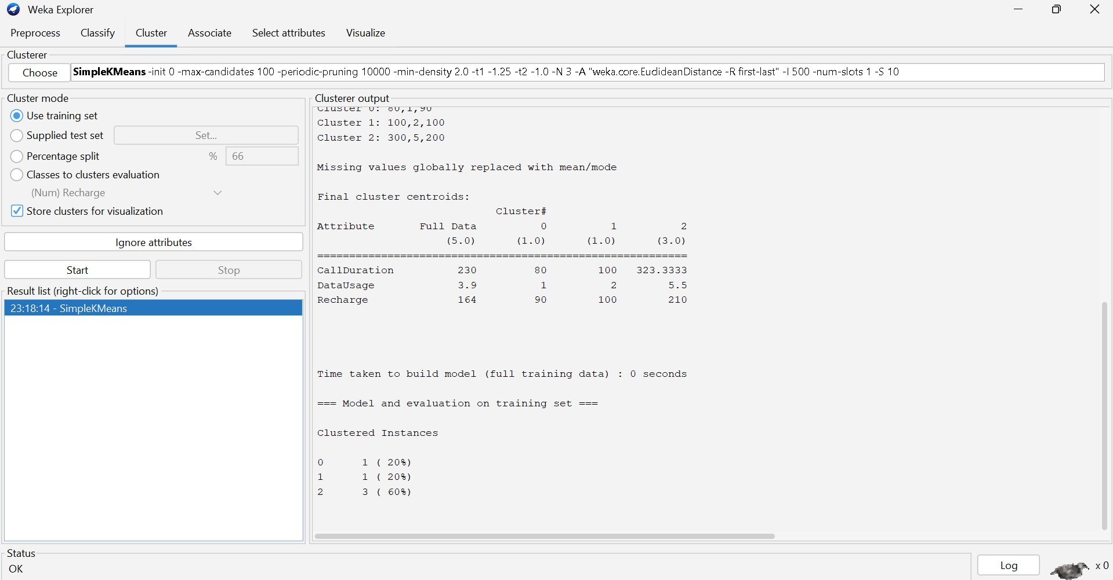

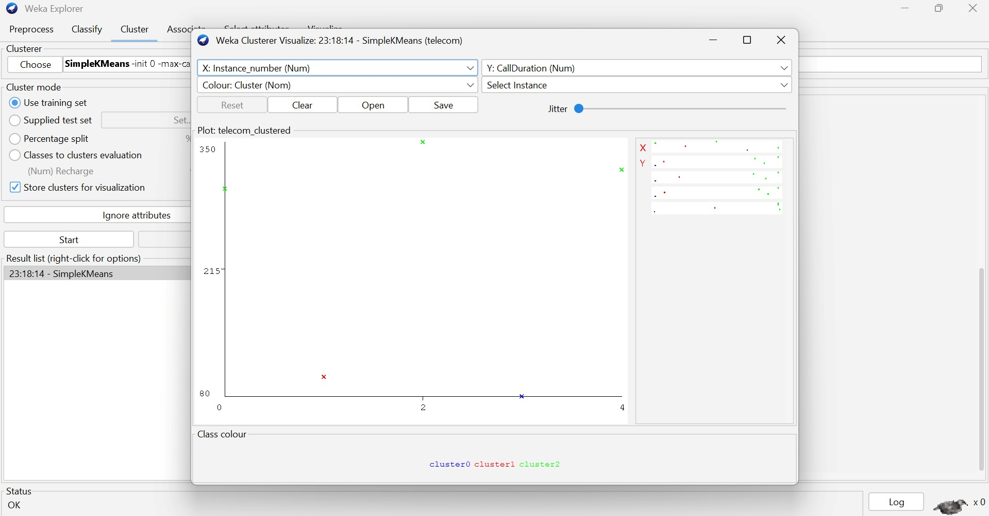

Analysis
With K = 2, users can be grouped approximately as:

● High-usage/high-value cluster: U1, U3, U5 ● Low-usage/low-value cluster: U2, U4
The low-usage group may represent customers with lower engagement and potentially higher churn risk.

Industry Application
The telecom company can provide personalized recharge plans, discounts, additional data benefits, and retention offers to low-engagement customers.
High-value customers can receive premium plans and loyalty benefits. Conclusion
Clustering helps telecom companies understand customer usage patterns and design targeted retention strategies. For accurate churn prediction, clustering should later be combined with historical churn data.

Q4 . Dataset: E-commerce Behavior User Product Views Clicks Purchases
U1 | 50 | 20 | 5
U2 | 30 | 10 | 2
U3 | 60 | 25 | 6
U4 | 20 | 8 | 1
U5 | 55 | 22 | 5
Question:
Suggest a clustering technique to group users and explain how it improves recommendation systems. (BL3 – 7 Marks)
ANSWER: E-Commerce Behavior

Clustering Technique: Hierarchical Clustering
Hierarchical clustering can group users according to their product views, clicks, and purchases. It is useful for discovering groups of users with similar browsing and purchasing behavior.

Input
User | Views | Clicks | Purchases
U1 | 50 | 20 | 5
U2 | 30 | 10 | 2
U3 | 60 | 25 | 6
U4 | 20 | 8 | 1
U5 55 22 5

OUTPUT:
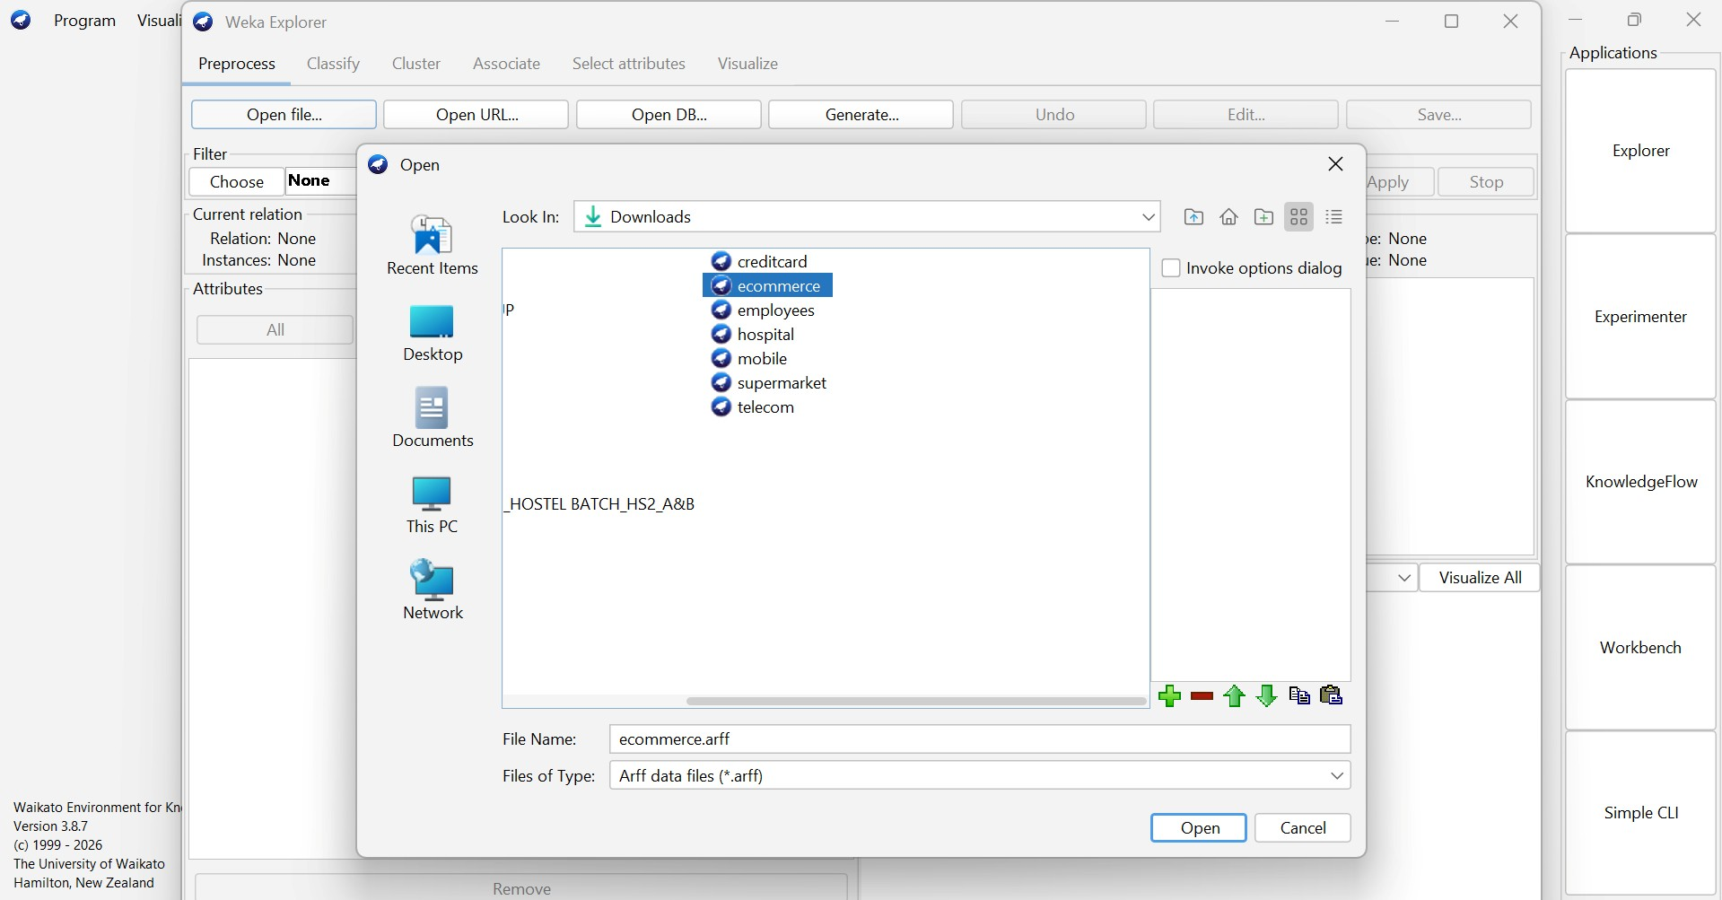

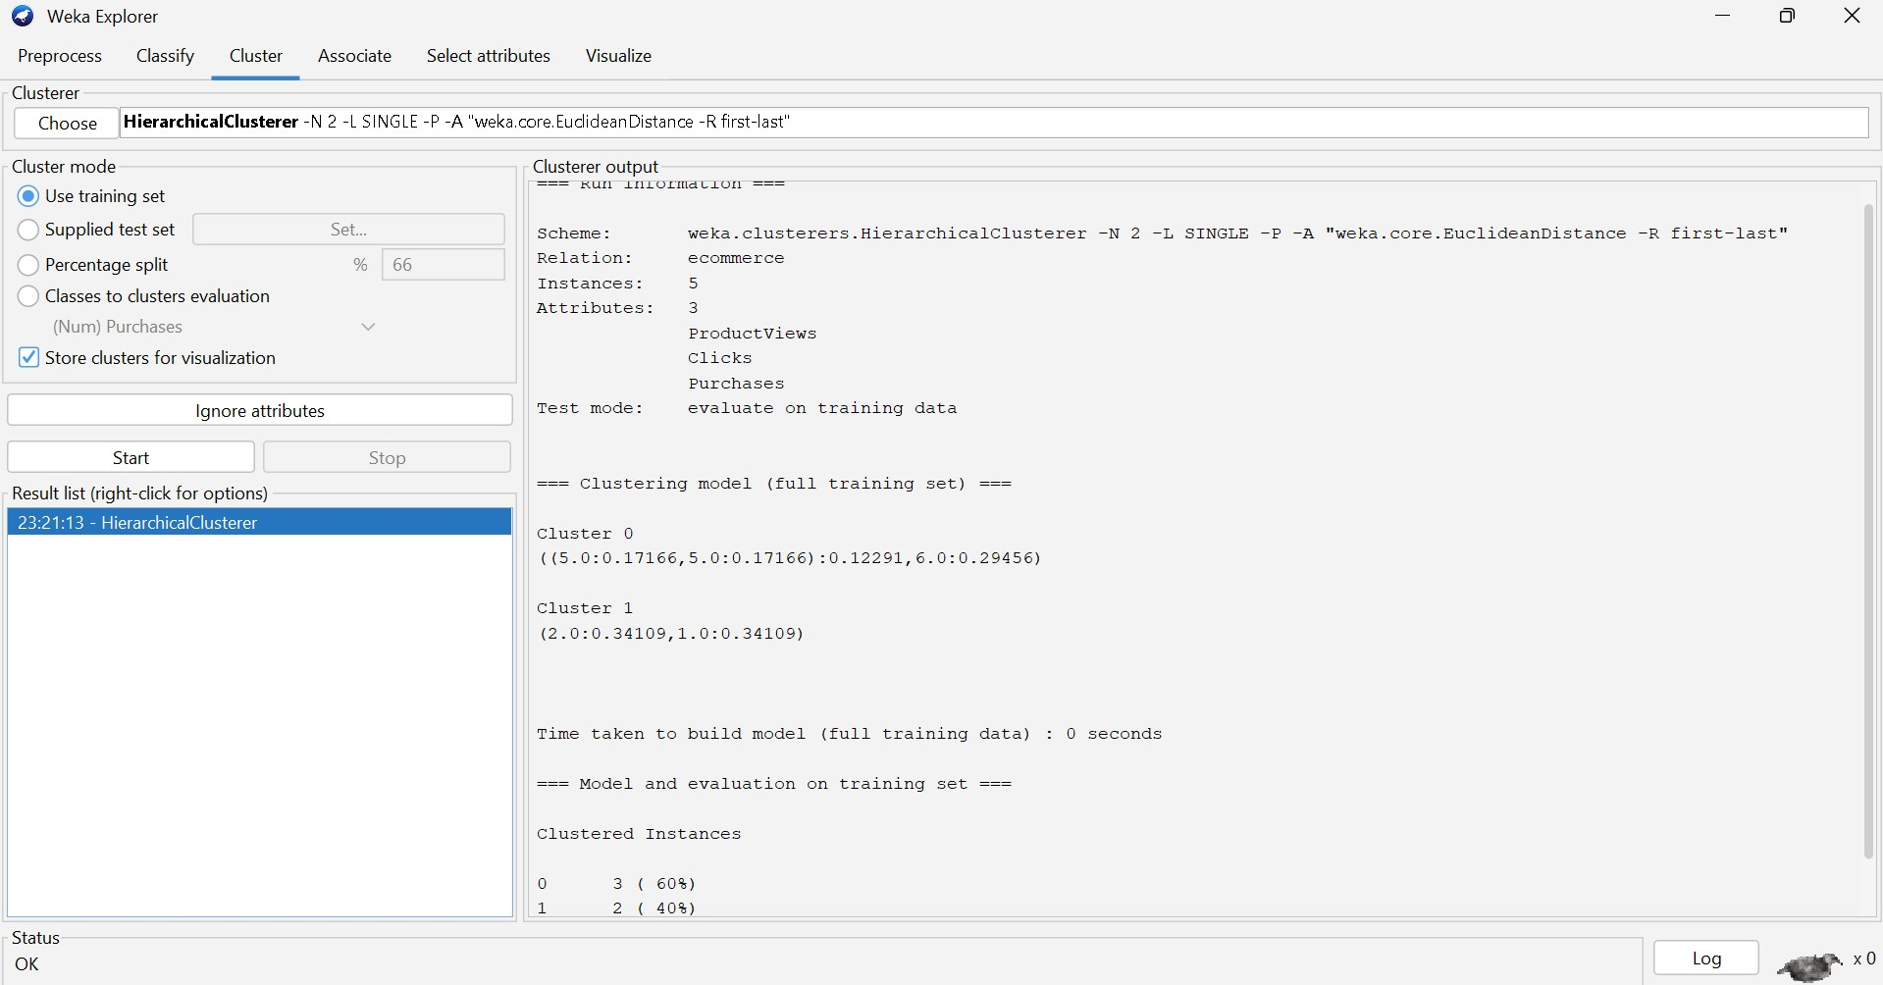

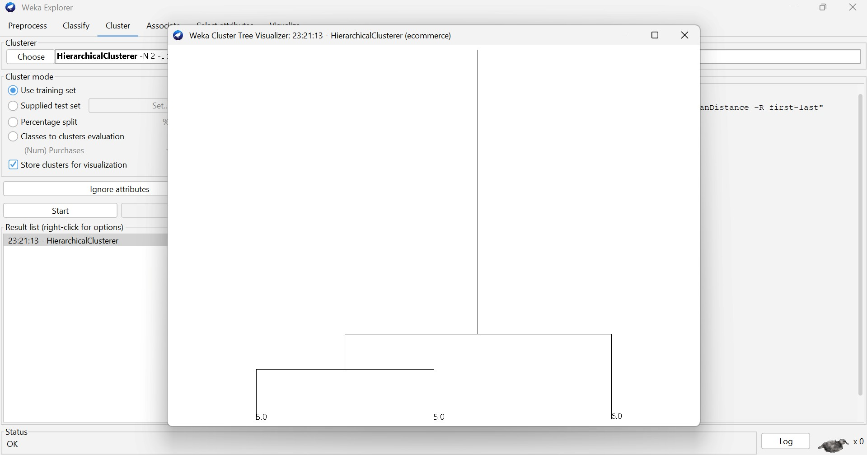

Analysis
Users U1, U3, and U5 show high engagement with many views, clicks, and purchases.
Users U2 and U4 show relatively lower engagement.
Therefore, the users can be grouped into:

● High-engagement customers: U1, U3, U5 ● Low-engagement customers: U2, U4 Industry Application
The recommendation system can use these clusters to provide personalized product recommendations.
High-engagement users can receive related products, premium products, and cross-selling recommendations. Low-engagement users can receive popular products, discounts, and promotional recommendations.

Conclusion
Hierarchical clustering helps identify behavioral customer groups, allowing e-commerce platforms to personalize recommendations and improve customer engagement.

Q5. Dataset: Traffic Data

Location Vehicle Count Avg Speed (km/h) Delay (min)
L1 | 200 | 30 | 10
L2 | 500 | 15 | 25
L3 | 220 | 28 | 12
L4 | 600 | 10 | 30
L5 | 210 | 32 | 9
Question:
Design a clustering-based solution to identify traffic congestion zones and explain how it helps in traffic management. (BL4 – 7 Marks)
ANSWER: Traffic Data

Clustering Technique: K-Means Clustering K-Means can group traffic locations using vehicle count, average speed, and delay. Input
Location | Vehicles | Avg Speed | Delay
L1 | 200 | 30 | 10
L2 | 500 | 15 | 25
L3 | 220 | 28 | 12
L4 | 600 | 10 | 30
L5 210 32 9

OUTPUT:
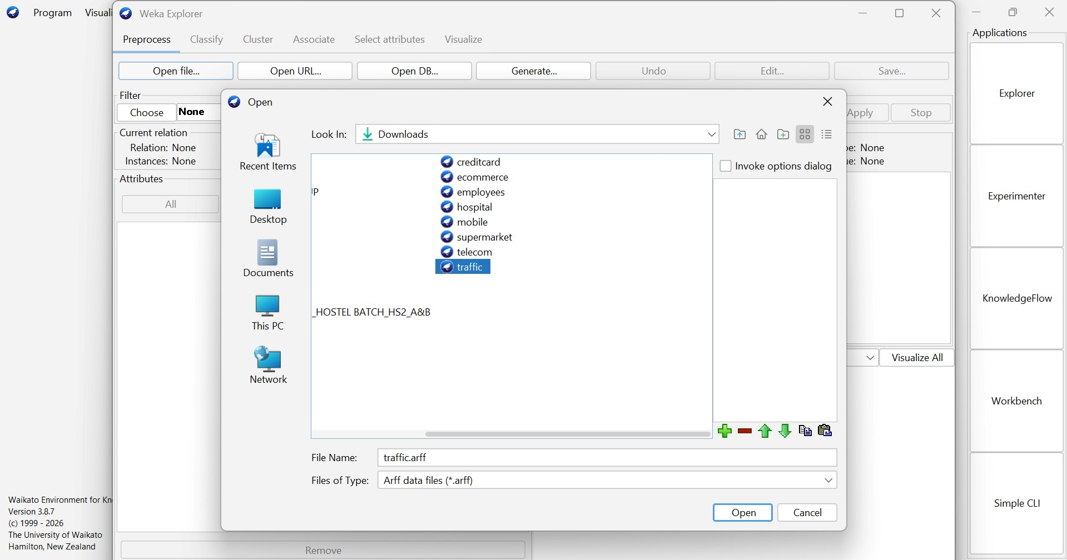

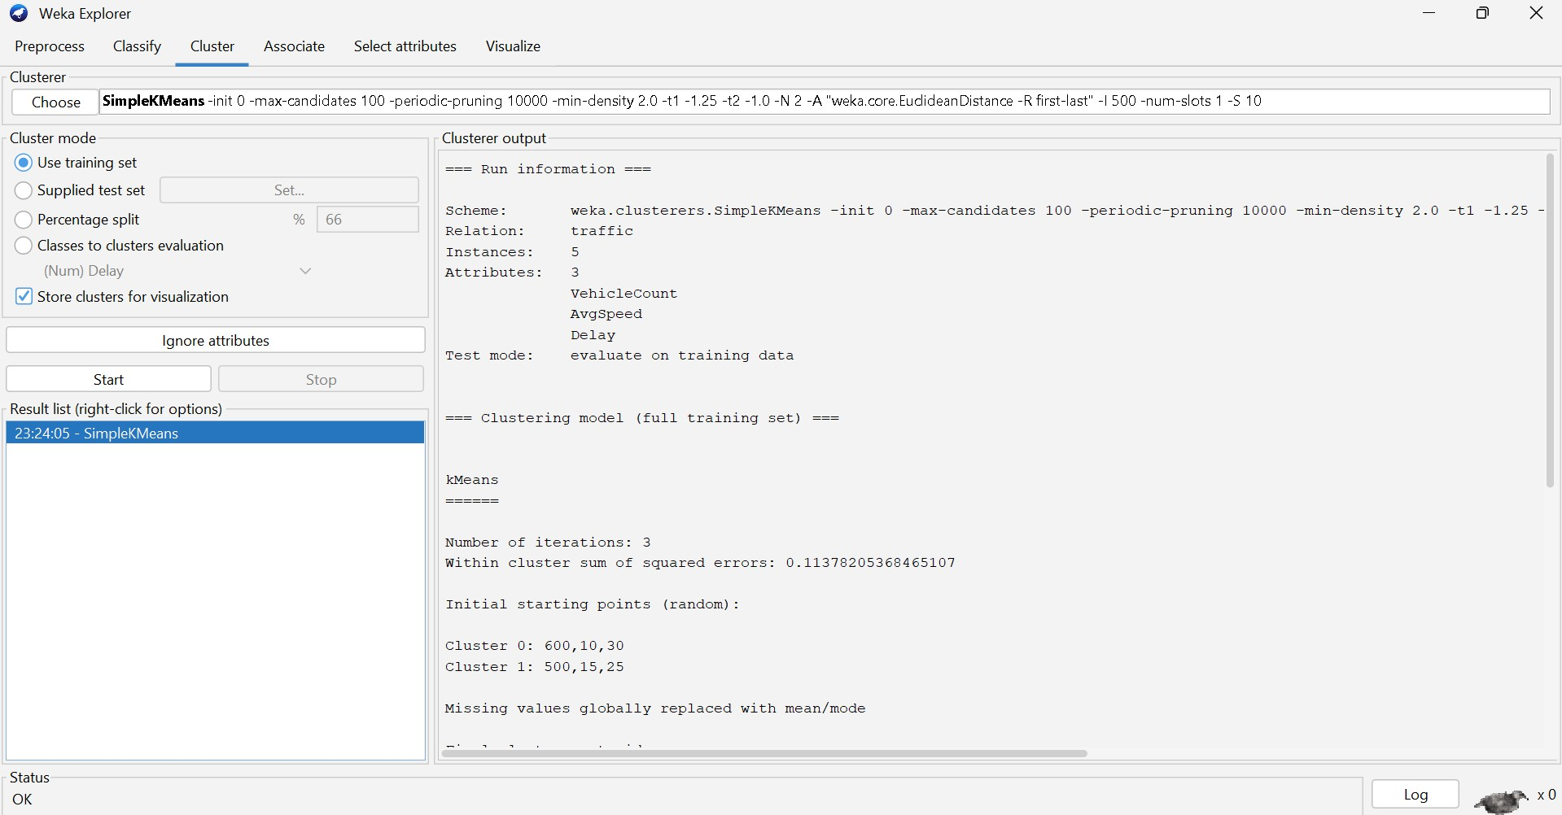

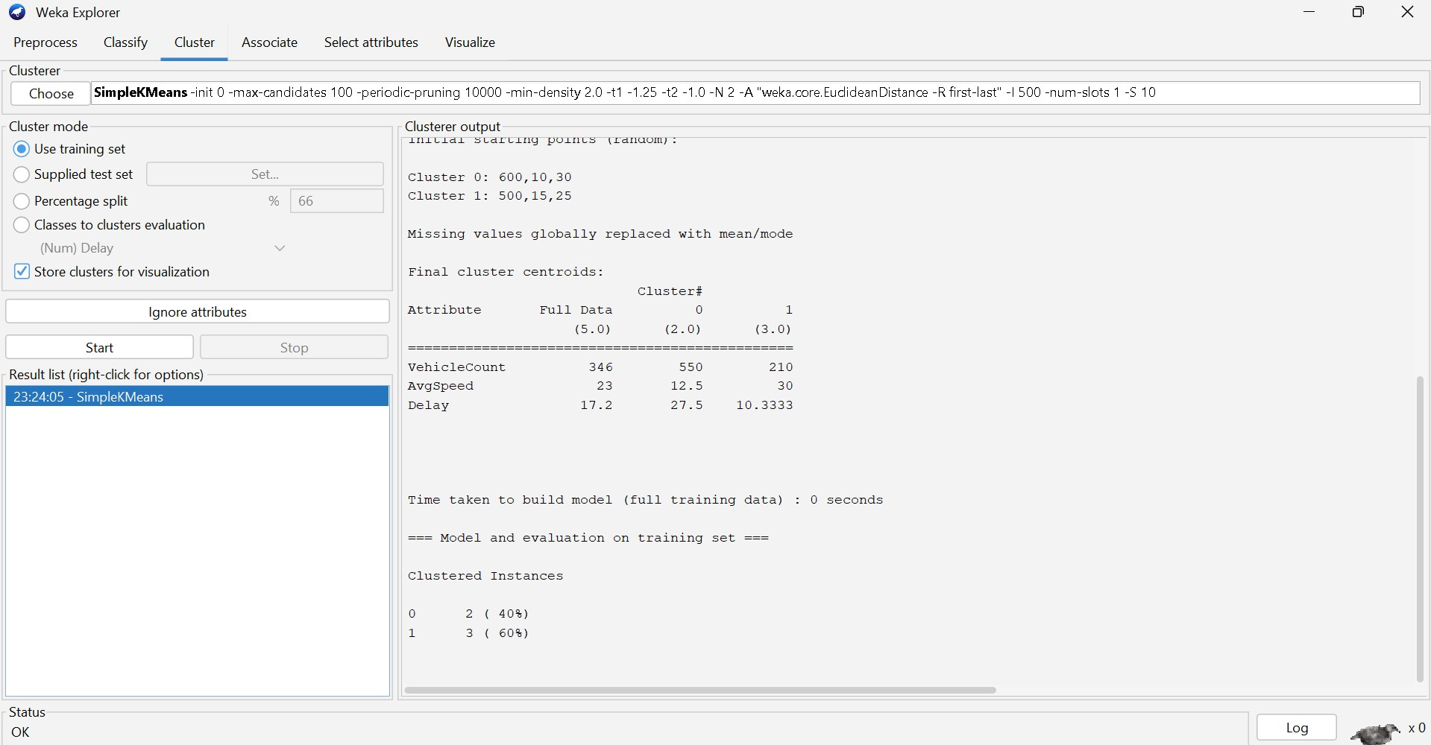

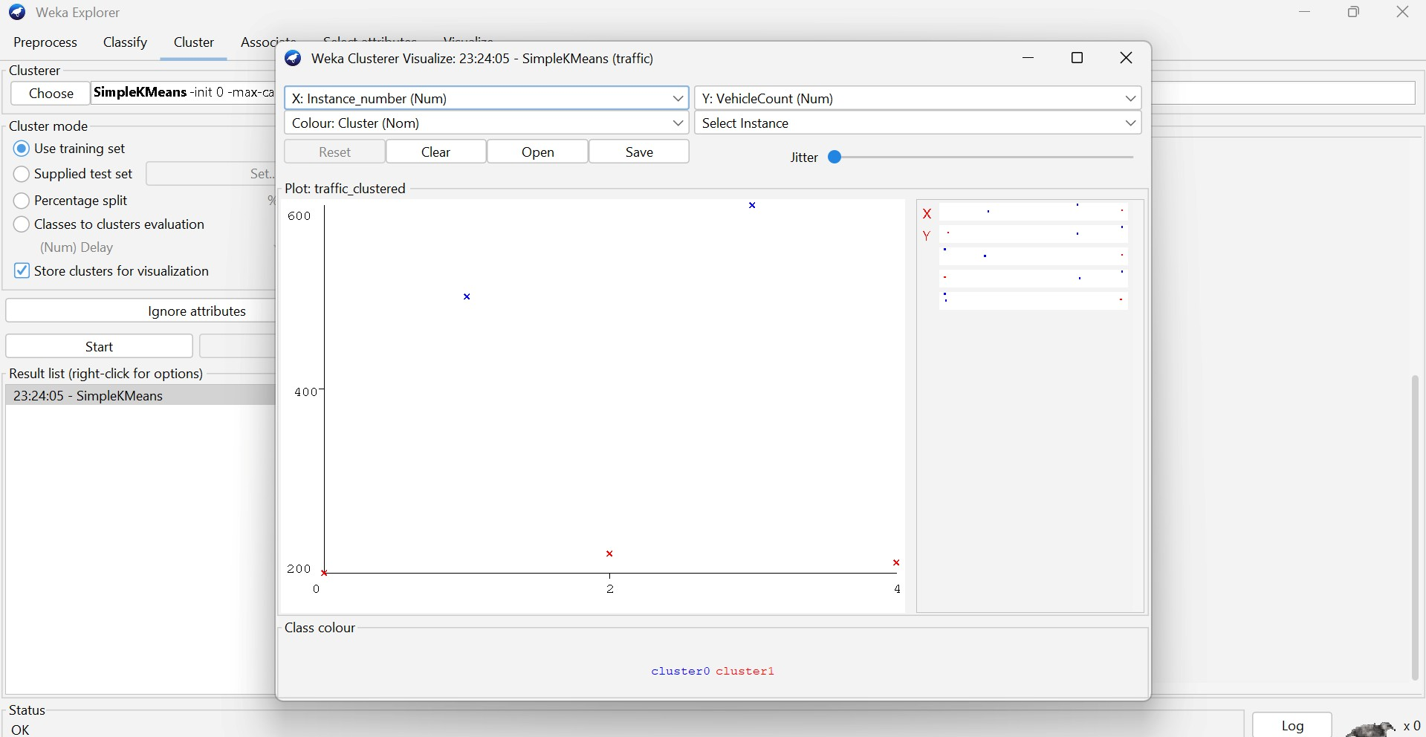

Analysis
With K = 2, the locations can be grouped approximately as:

● Low-congestion cluster: L1, L3, L5 ● High-congestion cluster: L2, L4
The high-congestion locations have high vehicle counts, low average speeds, and high delays. Industry Application
Traffic authorities can use these clusters to:
- Adjust traffic signals
- Deploy traffic personnel
- Provide alternate routes
- Manage traffic flow
- Send congestion alerts

Conclusion
K-Means clustering helps identify traffic congestion zones by grouping locations with similar traffic conditions. This supports data-driven traffic management and better allocation of traffic-control resources.

